Q1 A startup is building a new app to help domestic workers in Lahore find household jobs. No such app currently exists for this specific audience. A developer on the team says: "We don't need user research — we can just launch and see what happens."
(a) Identify one thing a needs assessment would uncover that a post-launch analysis cannot. [1 mark]
(b) At what stage should the needs assessment be conducted? [1 mark]

Q2 A team is designing a research protocol to understand how freelancers in Pakistan manage their finances and invoicing. A junior researcher drafts the following questions:
- "Can you tell me about a time when a client delayed your payment, what did you do?"
- "Do you use any apps to track your income?"
- "What is your biggest financial challenge as a freelancer?"
- "Why do most freelancers avoid using formal banking?

(a) Two of these questions are problematic. Identify them [1 mark]
(b) Rewrite one of the problematic questions to make it a strong interview question. [1 mark]

Q3 Look at the university course registration screen below. A student is trying to register for her chosen courses.
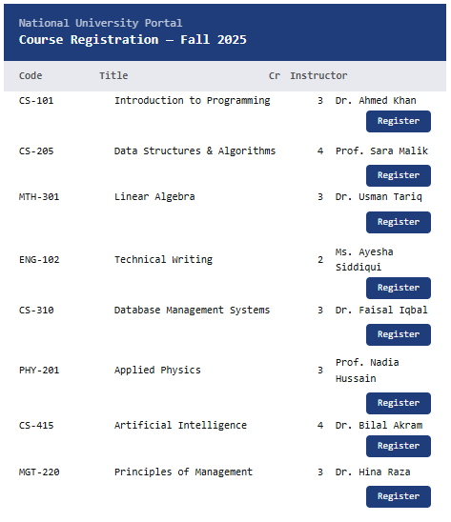
(a) Using the Gestalt principle of proximity, specify one issue with how the "Register" buttons are displayed and explain what is wrong with it. [1 mark]
(b) Suggest one specific layout change that would use proximity correctly to fix this problem. Suggest a redesign for the UI [2 marks]

